create database activity1;

show databases;

use activity1;

CREATE TABLE productions (

Productionid int NOT NULL,

Productionname varchar(30) NOT NULL,

Address varchar(40),

Dateofstarted YEAR,

Ownername varchar(20),

PRIMARY KEY (Productionid)

);

SELECT * FROM productions;

INSERT INTO productions(Productionid,Productionname,Address,Dateofstarted, Ownername) VALUES(9091,"Arkamediaworks","Hyderabad",2001,"Shobu Yarlagadda");

INSERT INTO productions(Productionid,Productionname,Address,Dateofstarted, Ownername) VALUES(8892,"Lyca Productions","Chennai",2014,"Subaskaran");

INSERT INTO productions(Productionid,Productionname,Address,Dateofstarted, Ownername) VALUES(1010,"Hari Om Entertainment","Mumbai",2008,"Akshay Kumar");

INSERT INTO productions(Productionid,Productionname,Address,Dateofstarted, Ownername) VALUES(1988,"Red Chillies Entertainment","Mumbai",2003,"Shah Ruck");

INSERT INTO productions(Productionid,Productionname,Address,Dateofstarted, Ownername) VALUES(1899,"Viacom 18 Studios","Mumbai",2008,"Ajit Andhare");

INSERT INTO productions(Productionid,Productionname,Address,Dateofstarted, Ownername) VALUES(7882,"DVV Entertainments","Hyderabad",1993,"DVV Danayya");

INSERT INTO productions(Productionid,Productionname,Address,Dateofstarted, Ownername) VALUES(6773,"Homable Films","Bangalore",1995,"Vijay");

INSERT INTO productions(Productionid,Productionname,Address,Dateofstarted, Ownername) VALUES(7682,"Mythri Movie Makers","Hyderabad",2015,"Naveen Yerneni");

INSERT INTO productions(Productionid,Productionname,Address,Dateofstarted, Ownername) VALUES(1854,"Junglee Pictures","Mumbai",2014,"Vineet Jain");

INSERT INTO productions(Productionid,Productionname,Address,Dateofstarted, Ownername) VALUES(2341,"CRM","Bangalore",2017,"Manohar");

INSERT INTO productions(Productionid,Productionname,Address,Dateofstarted, Ownername) VALUES(1111,"STP","Chennai",2018,"Sree");

create table movie

(

Movieid int NOT NULL PRIMARY KEY,

Moviename varchar(30),

Heroname varchar(30),

Heroine varchar(30),

Releaseddate DATE,

Language varchar(15),

Length int,

Movietype varchar(25),

Productionid int,

FOREIGN KEY (Productionid) REFERENCES productions(Productionid),

CHECK (Movieid<10000),

CHECK (Length>9 OR Length<100)

);

select * from movie;

SELECT * FROM movie;

INSERT INTO movie VALUES(201,"Bahubali-The Beginning","Prabhas","Tamannah",'2015-07-10',"Telugu",21,"Drama Fantasy",9091);

INSERT INTO movie VALUES(501,"2.0","Rajnikanth","Amy",'2018-11-29',"Tamil",20,"Scientific",8892);

INSERT INTO movie VALUES(577,"Aval","Siddharth","Andrea",'2017-11-03',"Tamil",14,"Horror",1899);

INSERT INTO movie VALUES(101,"Holiday","Akshay Kumar","Sonakshi",'2014-06-06',"Hindi",15,"Crime Thriller",1010);

INSERT INTO movie VALUES(151,"Zero","Shah Ruck","Katrina Kaif",'2018-12-21',"Hindi",16,"Scientific",1988);

INSERT INTO movie VALUES(131,"Padmavat","Shahid Kapoor","Deepika Padukone",'2018-01-25',"Hindi",21,"Drama Epic",1899);

INSERT INTO movie VALUES(146,"Andhadhun","Ayushmann","Radika Apte",'2018-10-05',"Hindi",16,"Crime Thriller",1899);

INSERT INTO movie VALUES(231,"Bharath Ane nenu","Mahesh Babu","Kiara",'2018-04-20',"Telugu",15,"Thriller",7882);

INSERT INTO movie VALUES(244,"Gruham","Siddharth","Andrea",'2018-11-17',"Telugu",14,"Horror",1899);

INSERT INTO movie VALUES(337,"KGF chapter 1","Yash","Srinithi Shetty",'2018-12-21',"Kannada",21,"Action Thriller",6773);

INSERT INTO movie VALUES(224,"Rangasthalam","Ram Charan","Samatha",'2018-03-30',"Telugu",17,"Drama Period",7682);

INSERT INTO movie VALUES(136,"Badhaai Ho","Ayushmann","Neena",'2018-10-18',"Hindi",14,"Drama Comedy",1854);

INSERT INTO movie VALUES(441,"The Villain","Sudeep","Amy",'2018-10-18',"Kannada",16,"Drama",2341);

INSERT INTO movie VALUES(206,"Maryada Ramanna","Sunil","Saloni",'2010-07-23',"Telugu",19,"Drama",9091);

INSERT INTO movie VALUES(211,"Khaidi No. 150","chiranjeevi","Kajal",'2017-01-17',"Telugu",20,"Drama Thriller",8892);

INSERT INTO movie VALUES(188,"Rangoon","Saif Ali Khan","Kangana",'2017-02-24',"Hindi",15,"Drama",1899);

INSERT INTO movie VALUES(189,"The House Next Door","Siddharth","Andrea",'2017-11-10',"Hindi",14,"Horror",1899);

INSERT INTO movie VALUES(267,"Anaganaga O Dheerudu","Siddharth","Shruthi",'2014-01-14',"Telugu",16,"Fantasy",9091);

#1----------------------------------------------------

SELECT Moviename,Movietype

FROM movie

WHERE Movietype LIKE 'Drama%';

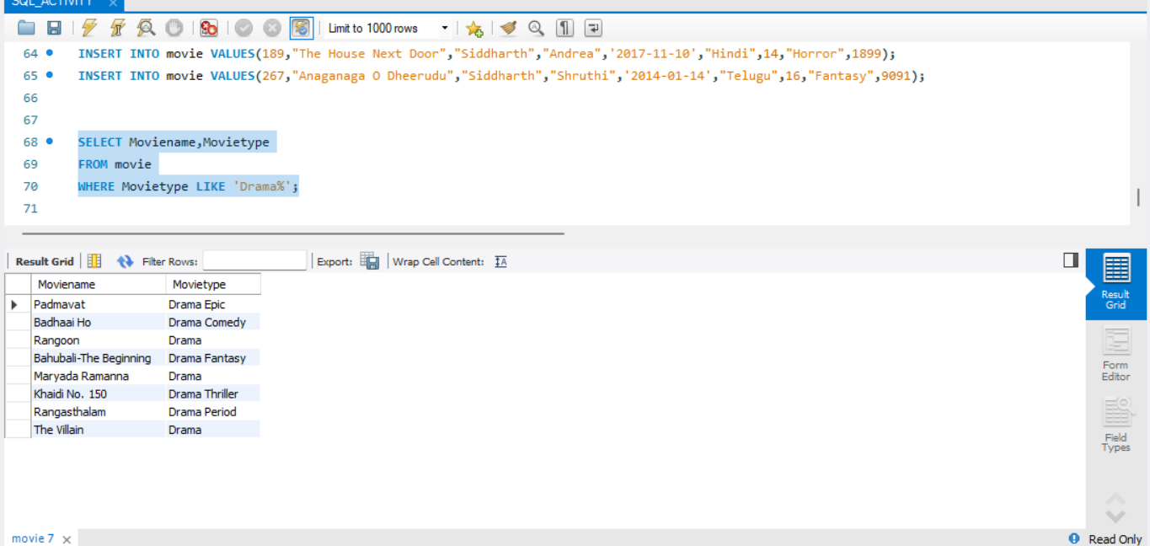#2----------------------------------------------------

SELECT Moviename,Heroname

FROM movie

WHERE Heroname='Ayushmann';

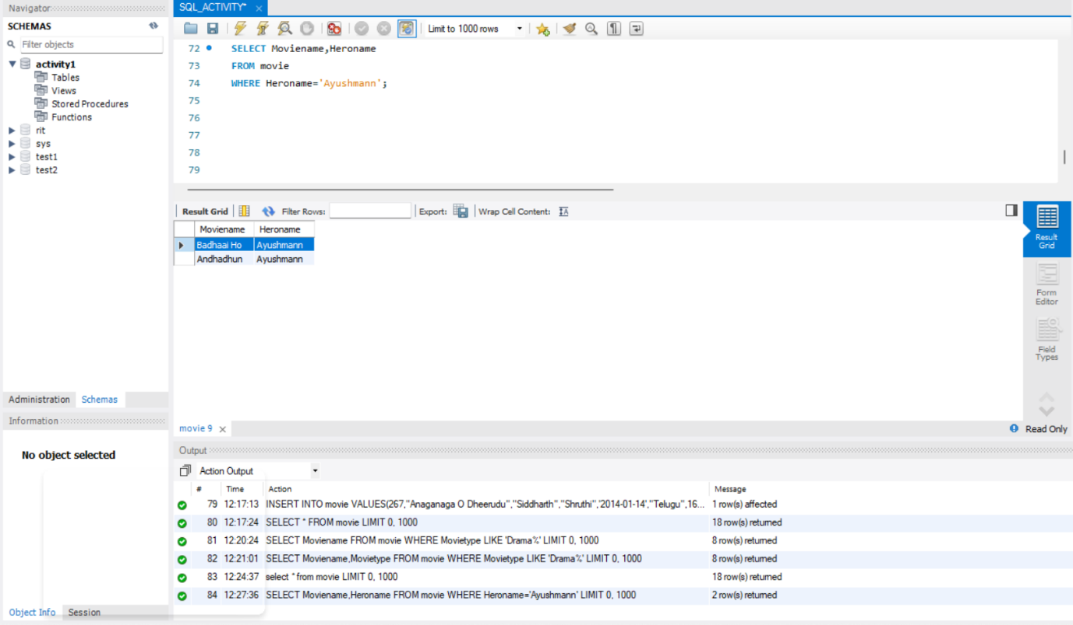

#3---------------------------------------------------

SELECT count(Moviename)

FROM movie

WHERE Length>18;

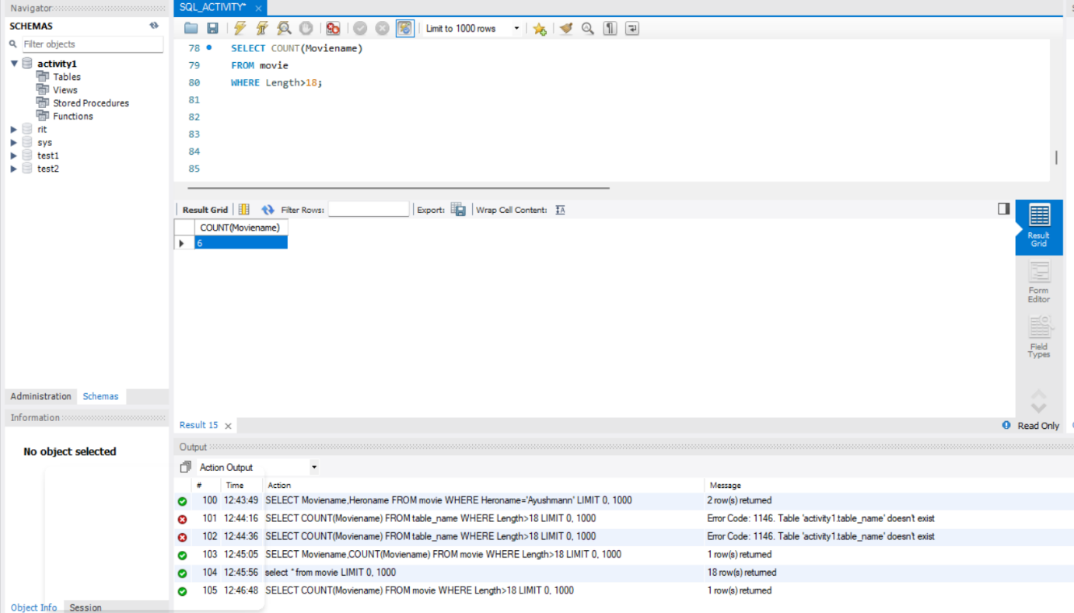

------------------------

#4 ----------------------------------------------------------------------------

SELECT Moviename,MIN(Length) as min_length from movie;

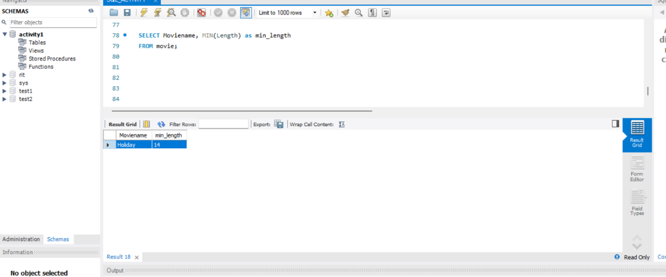

#5-------------------------------------------------------------

SELECT *

FROM movie

WHERE Language LIKE 'T%';

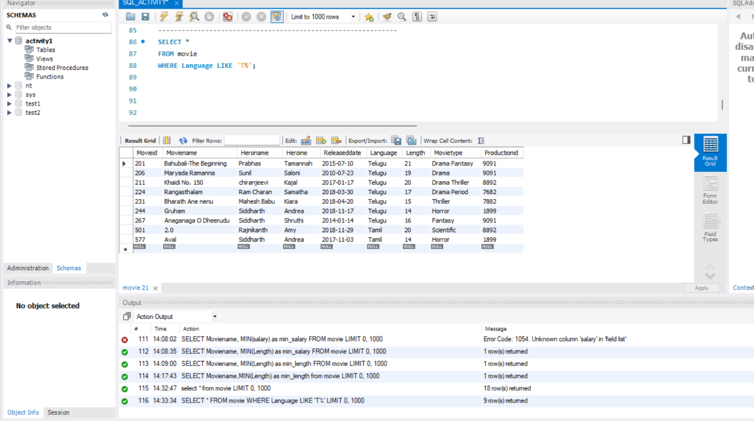

-------------------------------------------------------------

#6 ----------------------------------------------------------------------------

SELECT Moviename,Heroname,Heroine, MAX(Length) as max_length from movie;

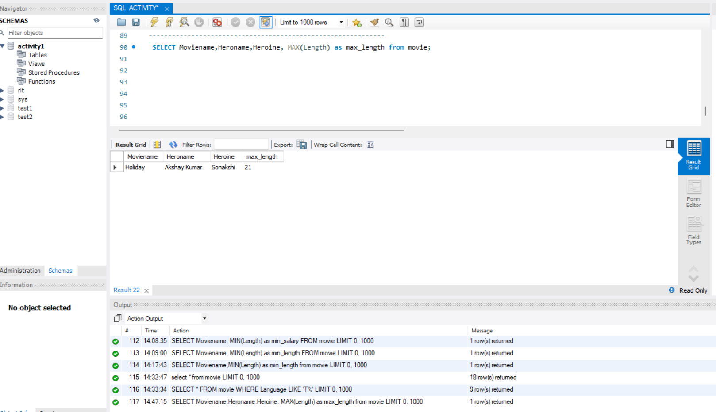

#7-----------------------------------------------------------------------------

SELECT Moviename,Heroname,Heroine

FROM movie

WHERE

Releaseddate > '2018-03-15';

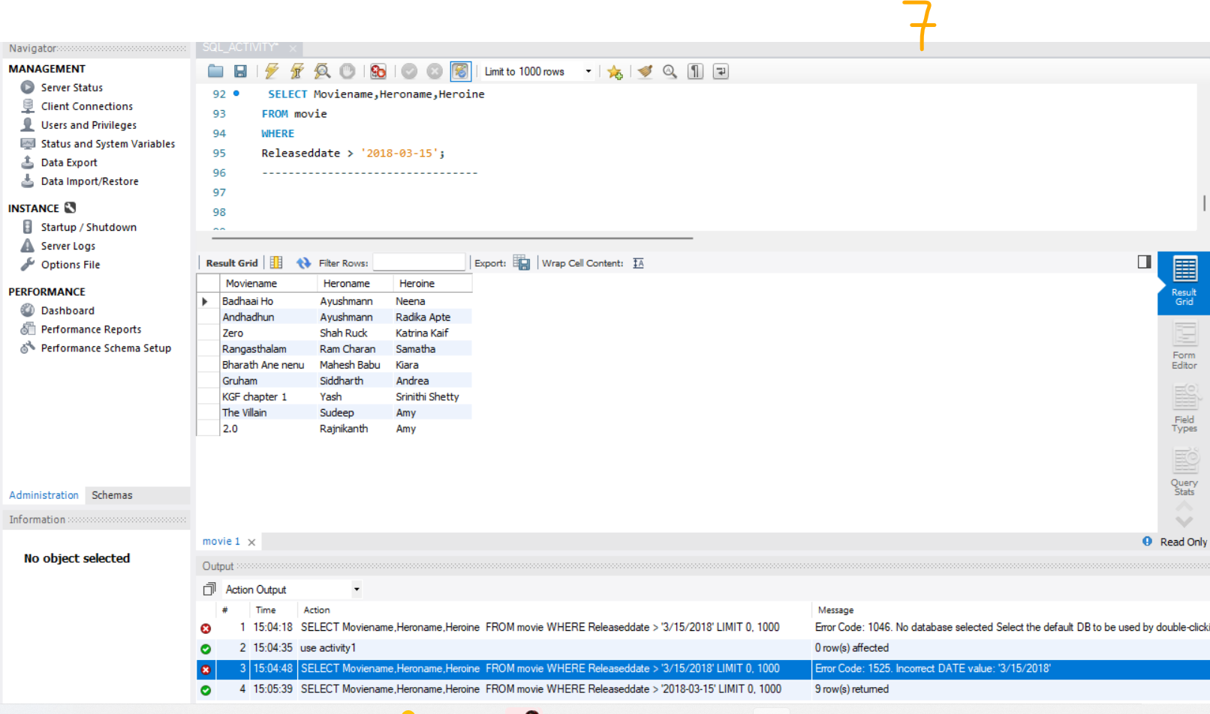

#8---------------------------------

SELECT Moviename,count(Moviename)

FROM movie

WHERE Movietype='Thriller';

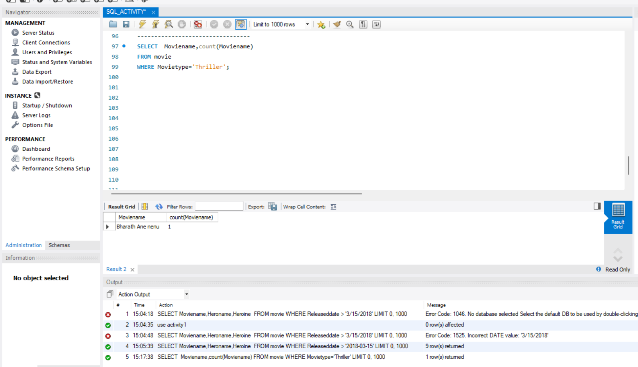

#9----------------------------------------

SELECT COUNT(Moviename)

FROM movie

WHERE

Releaseddate < '2018-03-15';

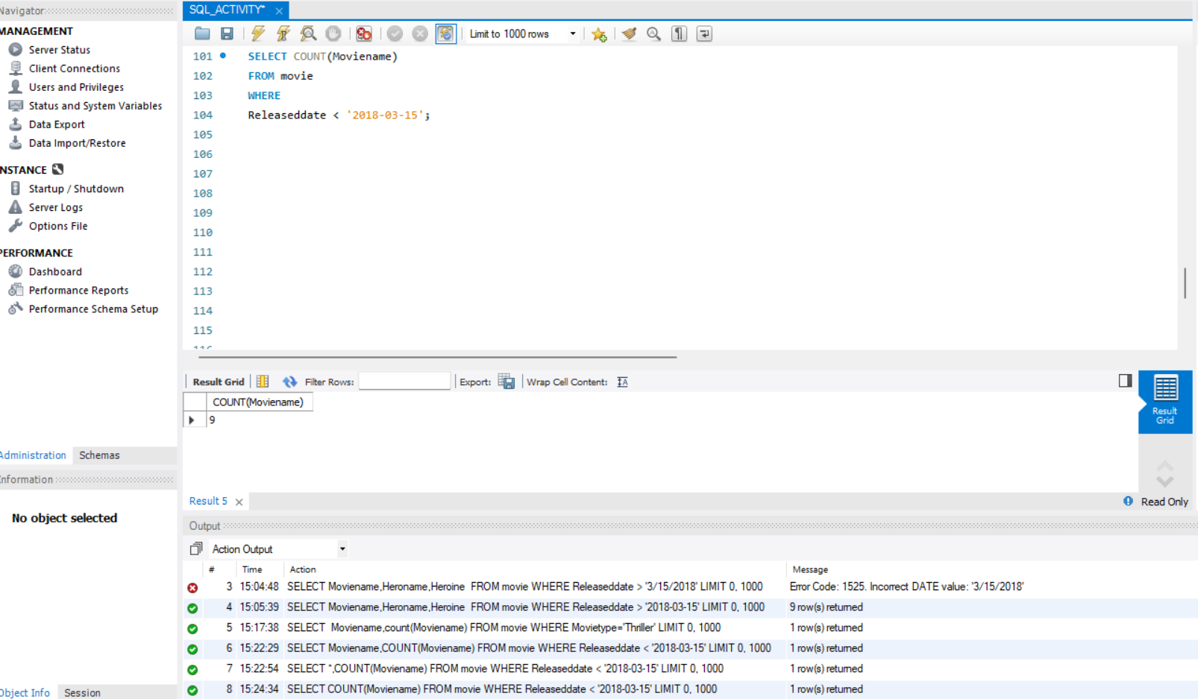

#10------------------------------------

SELECT Releaseddate

FROM movie

WHERE Moviename='Zero';

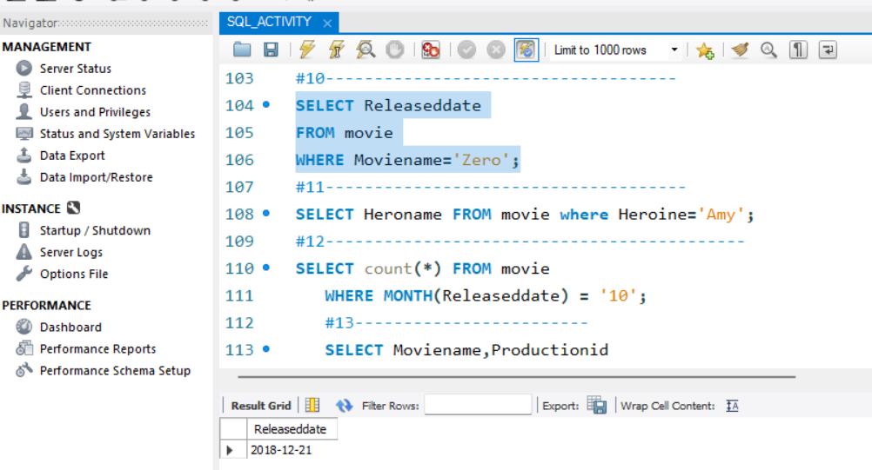

#11-------------------------------------

SELECT Heroname FROM movie where Heroine='Amy';

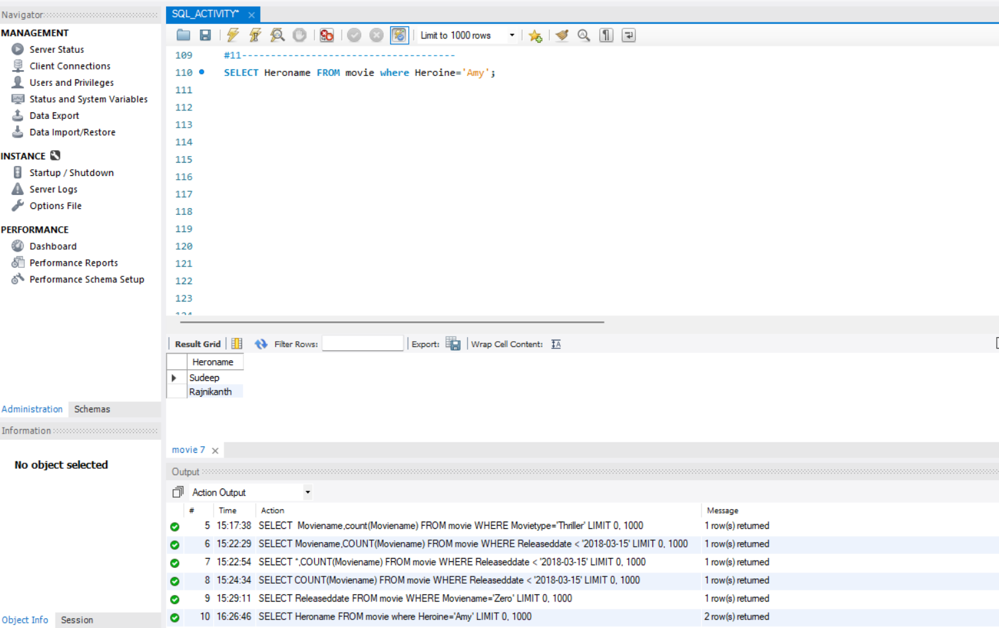

#12-------------------------------------------

SELECT count(*) FROM movie

WHERE MONTH(Releaseddate) = '10';

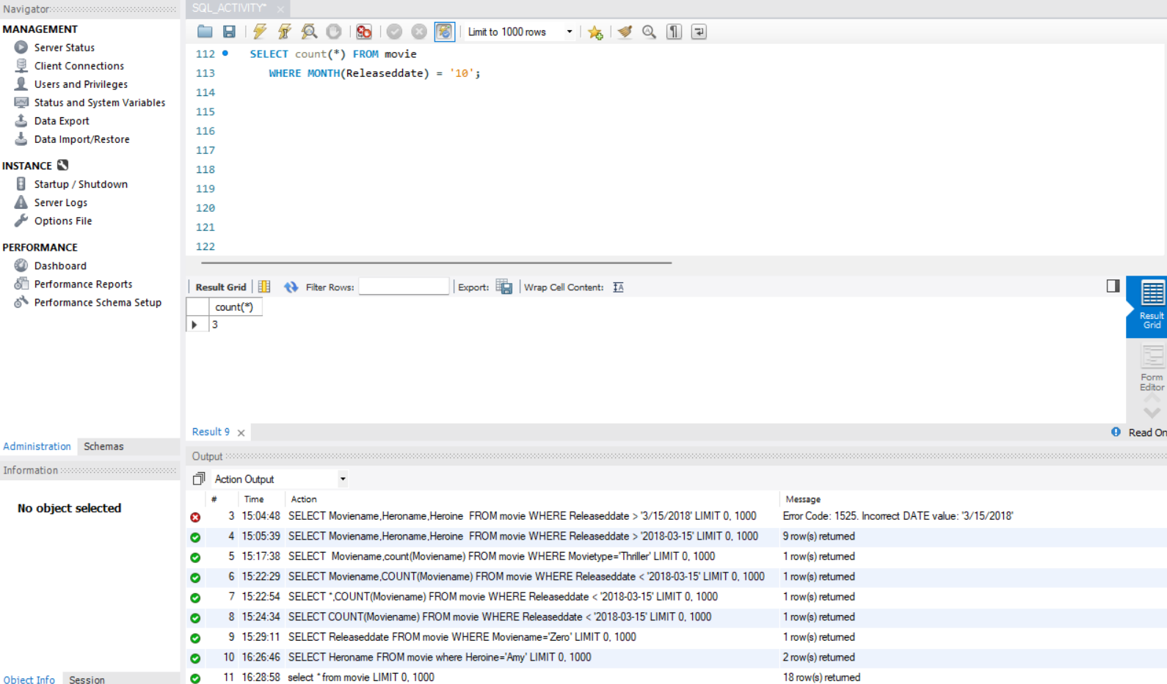

#13------------------------

SELECT Moviename,Productionid

FROM movie

WHERE Productionid IN

(SELECT Productionid FROM movie

GROUP BY Productionid

HAVING COUNT(*) > 1)

ORDER BY Productionid;

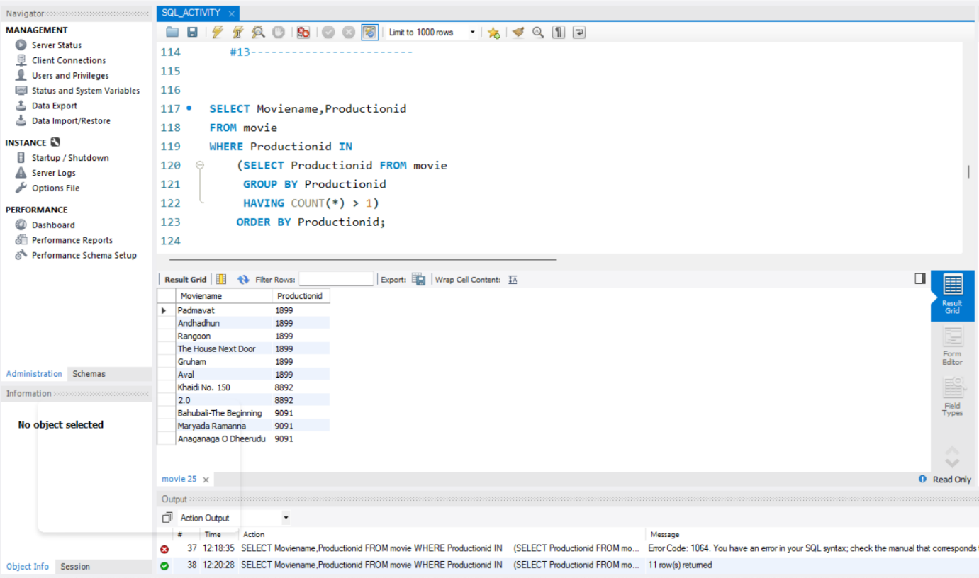

#14-----------------------------------------

SELECT Moviename FROM movie WHERE YEAR(Releaseddate)='2018';

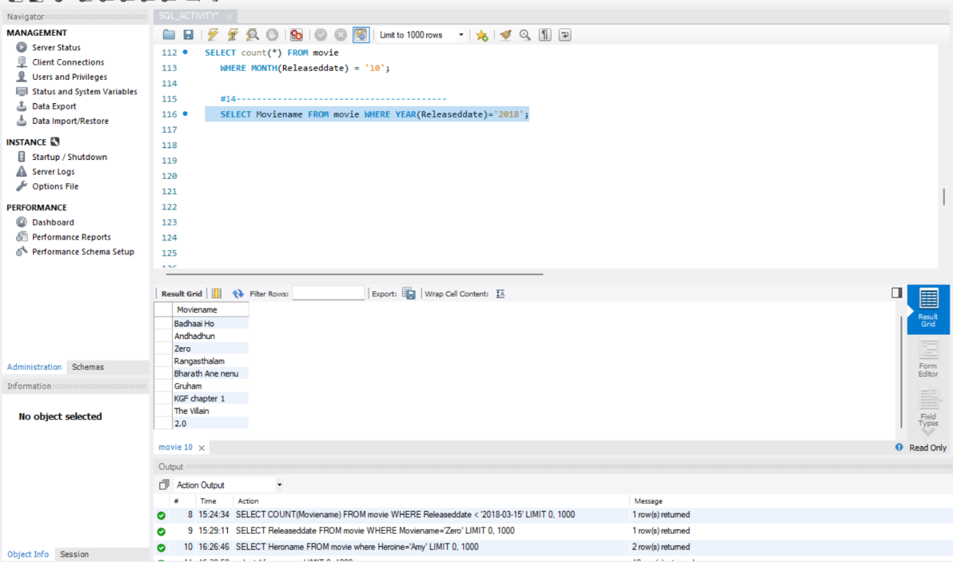

#15----------------------------------------------------------

SELECT UPPER(Moviename) From movie;

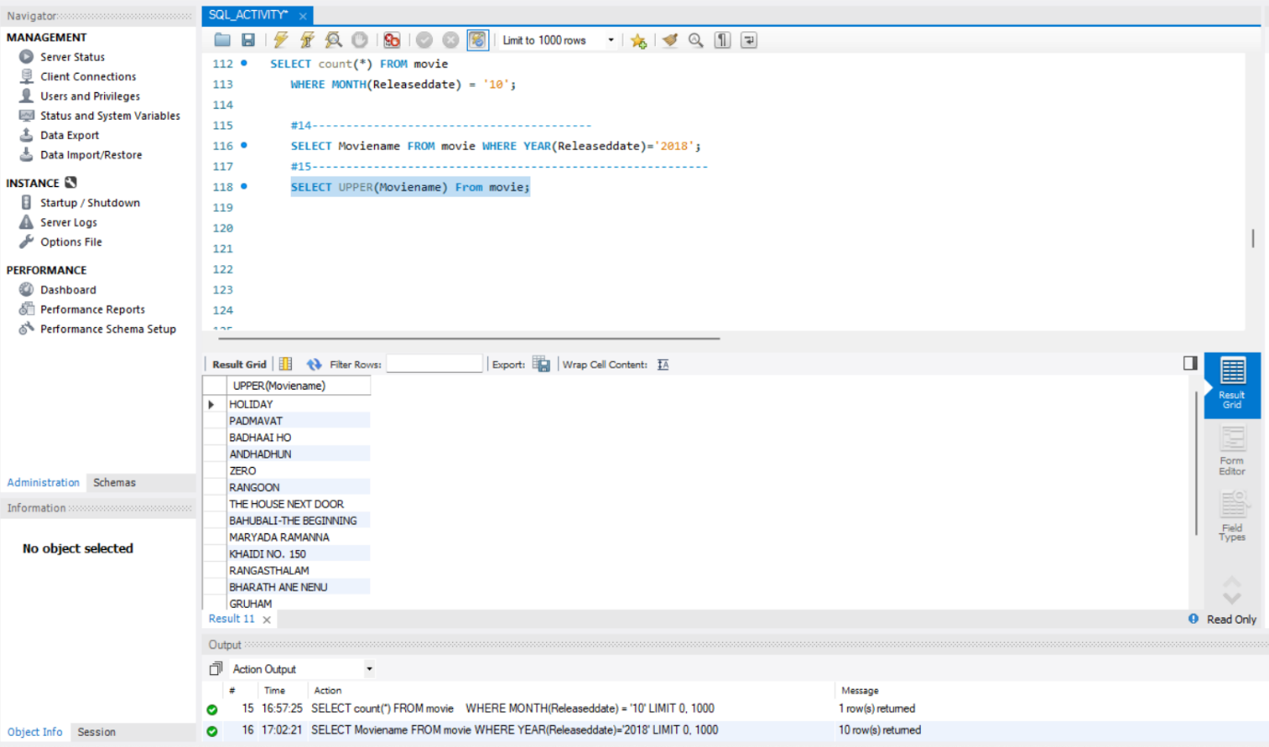

#16----------------------------------------

SELECT Moviename FROM movie ORDER BY MONTH(Releaseddate);

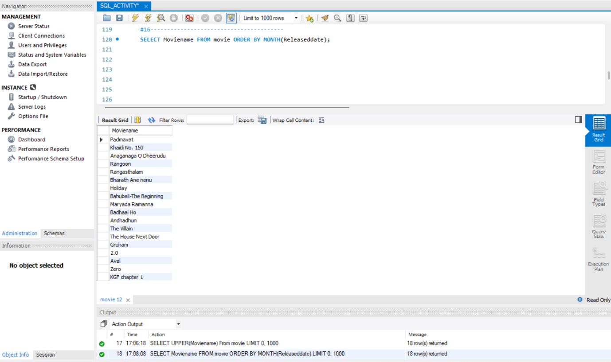

#17------------------------------------------------------

SELECT Heroname

FROM movie

WHERE Language = ALL

(SELECT Language

FROM movie);

